California State University, Los Angeles

Eco-Drive: Analyzing the Surge of Electric Vehicles and Their Impact in Washington State

Zalak Patel

Derek Abrego

CIS 5270-01: Business Intelligence

Dr. Shilpa Balan

13 May. 2024

**Table of Contents**

**Introduction _________________________________________________________1-2**

**Data Description Tables________________________________________________3-6**

**Data Cleaning________________________________________________________6-20**

**Statistic Summaries__________________________________________________20-31**

**Analysis Question #1_________________________________________________31-35**

**Analysis Question #2_________________________________________________35–39**

**Analysis Question #3_________________________________________________39–43**

**Conclusion_________________________________________________________43-44**

**References____________________________________________________________45**

**Introduction**

In recent years, Washington State has emerged as a leader in sustainable transportation, with a notable surge in electric vehicle (EV) adoption. This transition is reshaping the state’s automotive landscape, environmental footprint, infrastructure development, and economic policies. According to the *Washington State Standard*, “In March, there were about 181,400 electric vehicles registered in Washington, including plug-in hybrids, according to Department of Licensing data. That’s up from around 94,000 in March 2022” (Lucia, 2024). Most of the vehicles, “just over half of the EVs registered are in King County and around 40% are Tesla. Tesla prices its least expensive car, the Model 3, at about $39,000” (Lucia, 2024).

The dataset we will explore provides an in-depth look at the current population of Battery Electric Vehicles (BEVs) and Plug-in Hybrid Electric Vehicles (PHEVs) registered through the Washington State Department of Licensing (DOL). Battery Electric Vehicles (BEVs), which rely solely on electrical energy stored in batteries and charged from external power sources, represent a clean alternative to traditional combustion engines. Plug-in Hybrid Electric Vehicles (PHEVs), combining the flexibility of gasoline engines with the efficiency of electric motors, offer a practical solution for reducing emissions without fully depending on a battery's charge capacity. Both vehicle types are pivotal in the state’s strategy to decrease greenhouse gas emissions and promote renewable energy use. According to the *U.S. Energy Information Administration*, “Washington generates more hydroelectric power than any other state. In 2023, hydroelectric power accounted for 60% of Washington's total electricity net generation from both utility-scale (1 megawatt or larger) and small-scale (less than 1 megawatt) facilities (2024).

The dataset not only tracks the growth and types of electric vehicles but also includes detailed vehicle information of make and model, year of registration, and geographical distribution across counties. The dataset has been updated monthly, it reflects dynamic changes in registrations, offering insights into consumer behavior and the effectiveness of governmental policies aimed at boosting EV adoption.

Moreover, the dataset outlines the criteria for Clean Alternative Fuel Vehicle (CAFV) eligibility, crucial for understanding the fiscal incentives driving consumer choices. These incentives include sales and use tax exemptions, contingent on meeting specific price and electric-only range requirements outlined in recent legislation.

As we delve into this comprehensive analysis, we will evaluate the evolving EV infrastructure and examine the distribution of electrical utility providers across the county to find out which county has a better-prepared grid for electric vehicles. We will also uncover which counties have the most electric vehicles in their county. We will uncover the demographic trends of EV owners and assess which cities have the most EVs by mapping the residential coordinates of EV owners. Additionally, we will assess the environmental impact of increasing EV usage and analyze the electric range of the most popular electric vehicles by model and year. By examining these trends and data, we can forecast the future trajectory of electric mobility in the Evergreen State, highlighting both the challenges and opportunities that lie ahead in this green revolution.

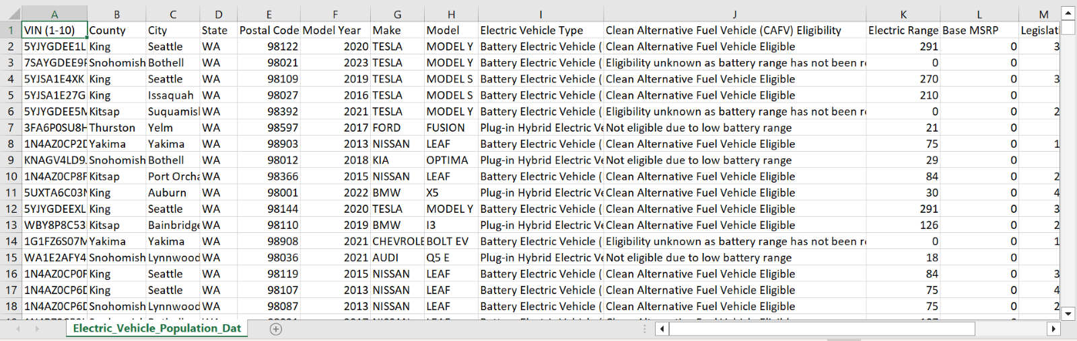  
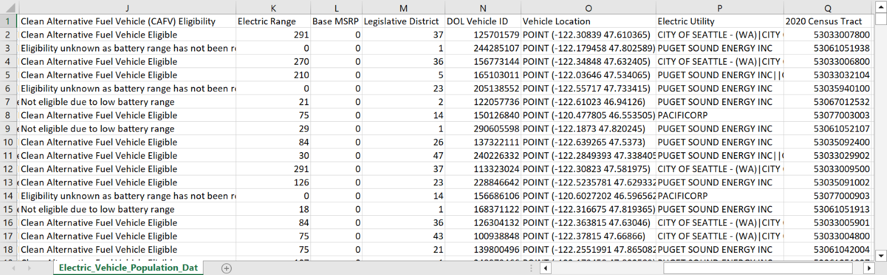  
**Dataset URL and Dataset Description**

The datasets used for this project are all from Kaggle.com. We have utilized the following datasets: "[Full Electric Vehicle Dataset 2024](https://www.kaggle.com/datasets/sahirmaharajj/electric-vehicle-population)," "[American EV Dataset](https://www.kaggle.com/datasets/uditdiwedidiwedi/american-ev-dataset?select=TESLA_DATA.csv)," and "[Electric Vehicle Population by Country (2024)](https://www.kaggle.com/datasets/sahirmaharajj/electric-vehicle-population-size-2024/data)”. I will be listing the dataset descriptions below

**Full Electric Vehicle Dataset 2024**

|  |  |  |  |
| --- | --- | --- | --- |
| **Column Name** | **Data Type** | **Description** | **Example** |
| VIN (1-10) | Alpha Numeric | Vehicle Identification Number | KNDJX3AE9H |
| County | Text | Residential County | Thurston |
| City | Text | Residential City | Olympia |
| State | Text | Residential State | WA |
| Postal Code | Integer | Residential Postal Code | 98502 |
| Model Year | Integer | Car Model Year | 2017 |
| Make | Text | Car Make Name | KIA |
| Model | Alpha Numeric | Car Model Name | SOUL EV |
| Electric Vehicle Type | Text | Electric Vehicle Type Battery or Hybrid | Battery Electric Vehicle (BEV) |
| Clean Alternative Fuel Vehicle (CAFV) Eligibility | Text | Clean Alternative Fuel Vehicle (CAFV) Eligibility Name | Clean Alternative Fuel Vehicle Eligible |
| Electric Range | Integer | Electric Range Total | 93 |
| Base MSRP | Integer | Car Base MSRP | 32250 |
| Legislative District | Integer | Residential Legislative District Name | 22 |
| DOL Vehicle ID | Integer | Department of Licensing Vehicle ID | 140569600 |
| Vehicle Location | Integer | Residential Vehicle Location | POINT (-122.92145 47.045935) |
| Electric Utility | Text | Residential Electric Utility Company | PUGET SOUND ENERGY INC |
| 2020 Census Tract | Integer | Residential 2020 Census Tract | 53067012002 |

**American Ev Dataset**

|  |  |  |  |
| --- | --- | --- | --- |
| **Column Name** | **Data Type** | **Description** | **Example** |
| country | Text | County Name | Snohomish |
| City | Text | City Name | Edmonds |
| Postal Code | Integer | Postal Code Number | 98020 |
| Model Year | Integer | Model Year Number | 2013 |
| make | Text | Car Make Name | TESLA |
| Model | Text | Model Name | MODEL S |
| Electric Vehicle Type | Text | Electric Vehicle Type Name | Battery Electric Vehicle |
| CAFV | Text | Clean Alternative Fuel Vehicle Name | Clean Alternative Fuel Vehicle Eligible |
| Electric Range | Integer | Electric Range Mileage | 208 |
| Base MSRP | Integer | Base MSRP | 69900 |
| Legislative District | Integer | Legislative District Mileage | 21 |
| DOL Vehicle ID | Integer | Department of Licensing Vehicle ID | 186212960 |
| Electric Utility | Text | Residential Electric Utility Company | PUGET SOUND ENERGY INC |
| Longitude | Integer | Longitude of Residential Vehicle Location | -122.37507 |
| Latitude | Integer | Latitude of Residential Vehicle location | 47.80807 |

**Electric Vehicle Population by Country (2024)**

|  |  |  |  |
| --- | --- | --- | --- |
| **Column Name** | **Data Type** | **Description** | **Example** |
| Date | Alphanumeric | Month-Day-Year | September 30 2022 |
| County | Text | County Name | Riverside |
| State | Text | State Abbreviation | CA |
| Vehicle Primary Use | Text | Vehicle Primary Use Name | Passenger |
| Battery Electric Vehicles (BEVs) | Numeric | Total BEVs | 7 |
| Plug-In Hybrid Electric Vehicles (PHEVs) | Numeric | Total Plug-In Hybrids | 0 |
| Electric Vehicle (EV) Total | Numeric | EV Totals | 7 |
| Non-Electric Vehicle Total | Numeric | Non-Electric Vehicle Totals | 460 |
| Total Vehicles | Numeric | Total Vehicles | 467 |
| Percent Electric Vehicles | Numeric | Percent of Electric Vehicles | 1.5 |

**Data Cleaning: Full Electric Vehicle Dataset 2024**

The data-cleaning process will begin with the following Python code:

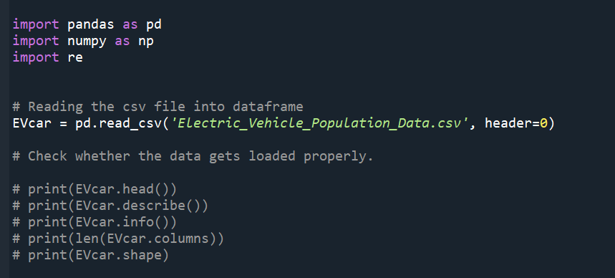

1. **Cleaning Electric Vehicle Type Column:**

The Full Electric Vehicle Dataset 2024 includes a column titled "Electric Vehicle Type", which specifies whether a vehicle is a "Battery Electric Vehicle (BEV)" or a "Plug-in Hybrid Electric Vehicle (PHEV)". Our goal is to clean this column to display only "BEV" or "PHEV" for simplicity and effective visualization.

**Pre-Cleaning:**

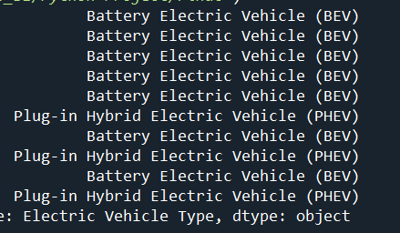

**Full Interface:**

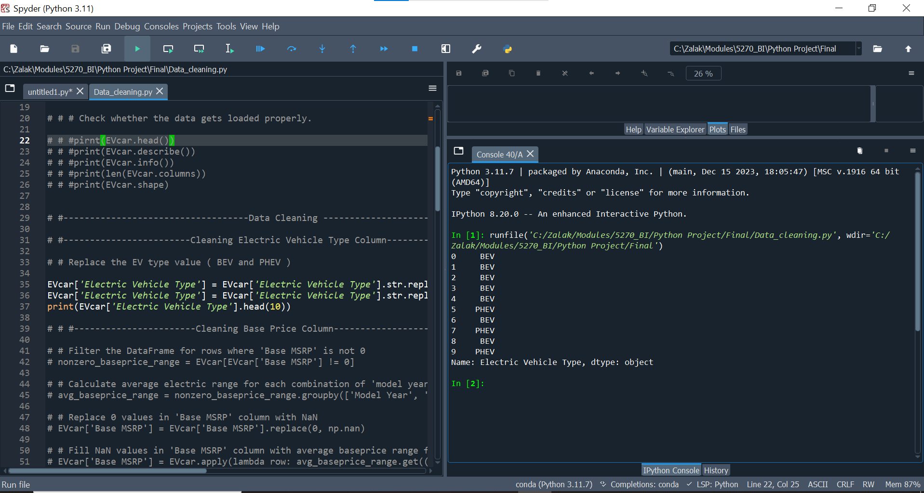

**Python Code:**

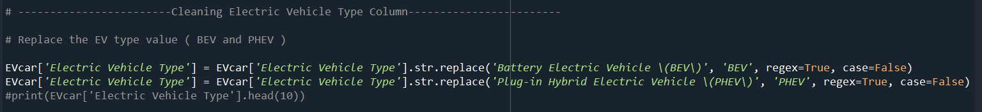

**Post-Cleaning:**

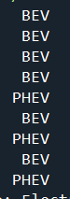

1. **Cleaning The Base Price MSRP Column**

The Full Electric Vehicle Dataset 2024 includes a column titled "Base MSRP," which specifies the base MSRP of different electric vehicle models. Our goal is to clean this column by replacing zero values with the average Base MSRP based on Model year and Model. To accomplish this, we first calculated the average base price range for each combination of 'Model Year' and 'Model' by filtering out the zero values. We will then replace zero values with the corresponding average base price range for each combination of 'Model Year' and 'Model'.

**Pre-Cleaning:**

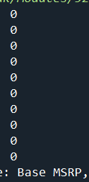

**Full Interface:**

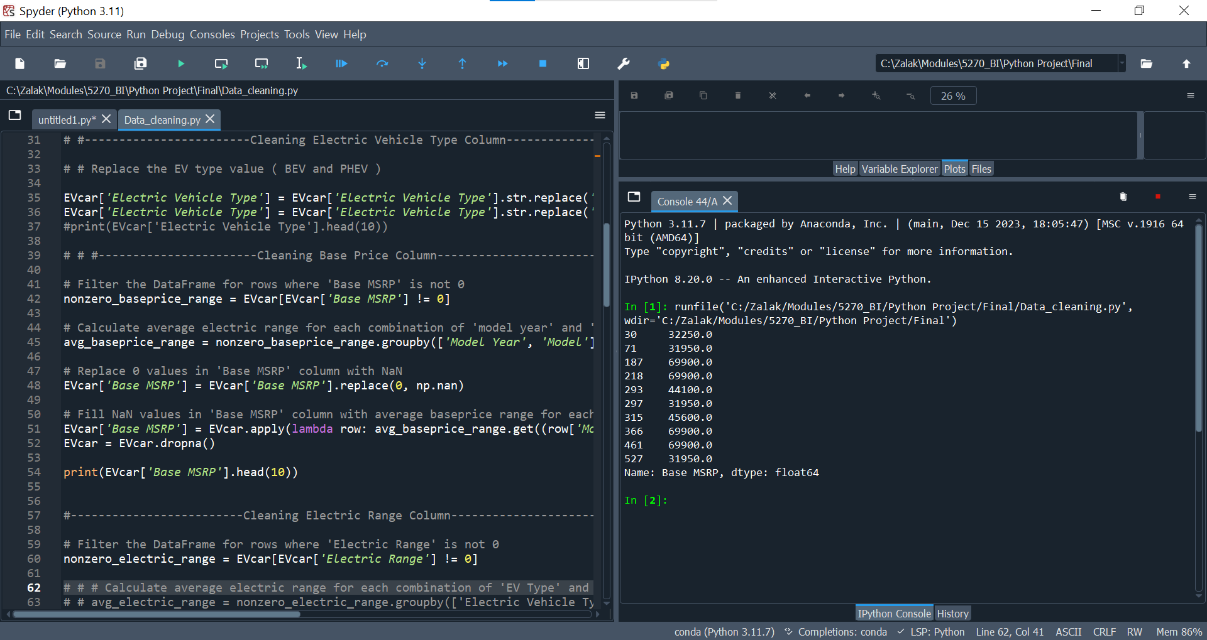

**Python Code:**

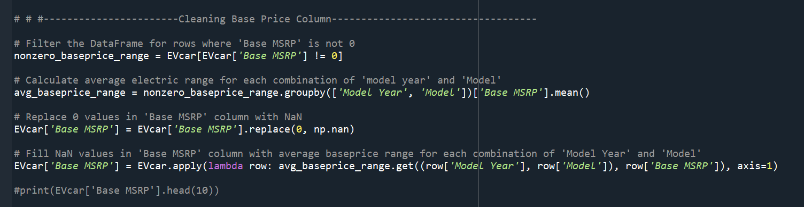

**Post-Cleaning:**

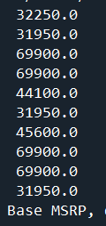

1. **Cleaning Electric Range Column**

Another data column we cleaned in the Full Electric Vehicle Dataset 2024 is titled “Electric Range”, which indicates the electric range mileage for each vehicle. To address zero values in this column, we located the zero values, calculated the average electric range by vehicle type and model based using non-zero values, and replaced the zero values with these averages.

**Pre-Cleaning:**

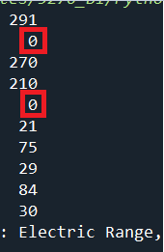

**Full Interface:**

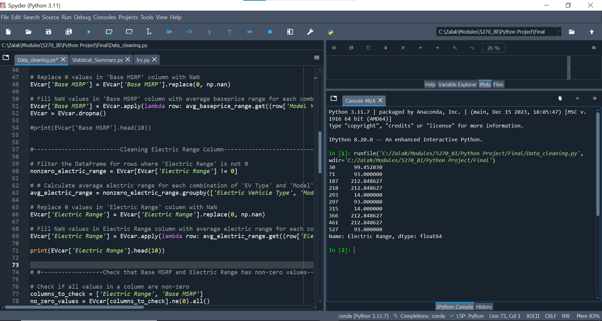

**Python Code:**

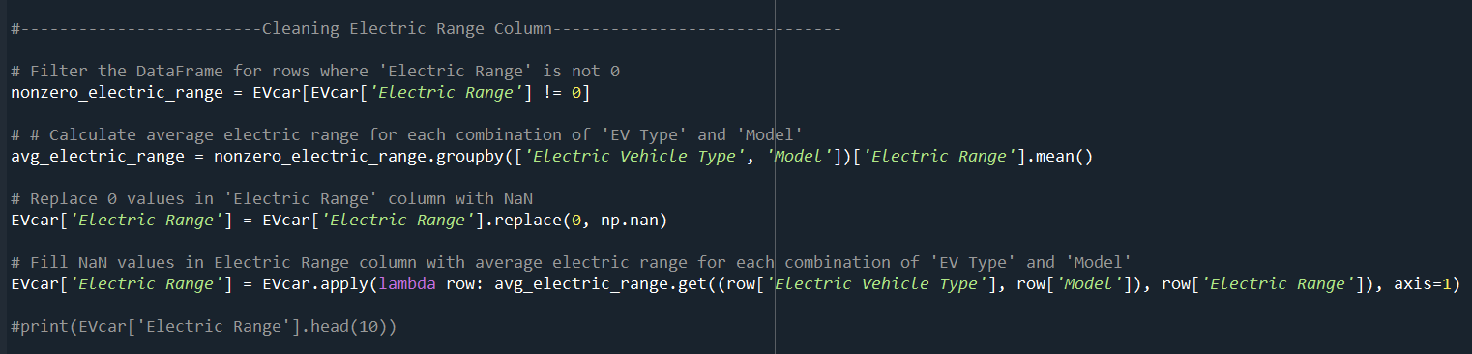

**Post-Cleaning:**

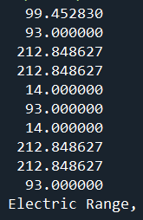

After cleaning the Base MSRP column and the Electric Range column, we need to ensure that both columns do not contain any zero values. We can verify this using the following Python code:



1. **Cleaning The Clean Alternative Fuel Vehicle (CAFV) Eligibility Column**

The “Clean Alternative Fuel Vehicle (CAFV) Eligibility” column was cleaned to make it easily readable and indicate whether a car is eligible for CAFV. Before cleaning, the column contained three values: “Clean Alternative Fuel Vehicle Eligible”, “Not eligible due to low battery range” and “Eligibility unknown as battery range has not been researched”. After cleaning, the values were standardized "Eligible", "Not Eligible" and “Unknown Eligibility”. The Python code below will show how we used the rename and replace function to clean our data.

**Pre-Cleaning:**

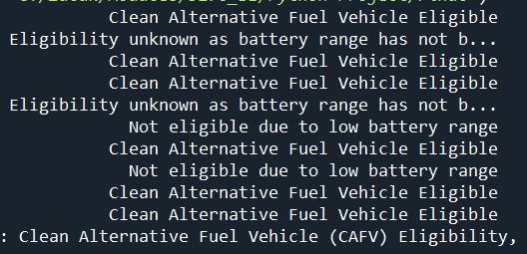

**Full Interface:**

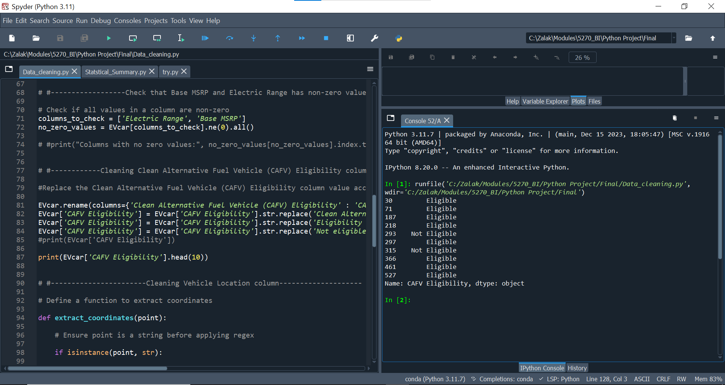

**Python Code:**

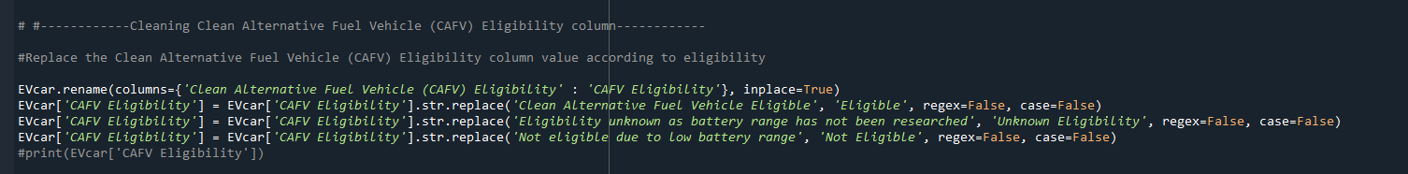

**Post-Cleaning:**

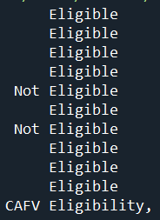

1. **Cleaning Vehicle Location column**

The second to last in our data cleaning process for the Full Electric Vehicle Dataset 2024 was addressing the "Vehicle Location" data column. This column contains the coordinates of the residential location of each electric vehicle. The issue was that the coordinates were stored in a single column, but for mapping purposes, latitude and longitude needed to be separated.

To achieve this, we extracted the geographic coordinates from the 'Vehicle Location' column, which contains data in the format POINT (longitude latitude). We implemented a custom function, extract coordinates, to transform this data into separate latitude and longitude columns.

We applied the extract coordinates function to each entry in the 'Vehicle Location' column of the EVcar Data Frame using the apply method, which applies the function to each element in the column. The resulting latitude and longitude values were then unpacked into two new columns: 'latitude' and 'longitude'.

**Pre-Cleaning:**

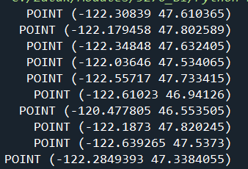

**Full Interface:**

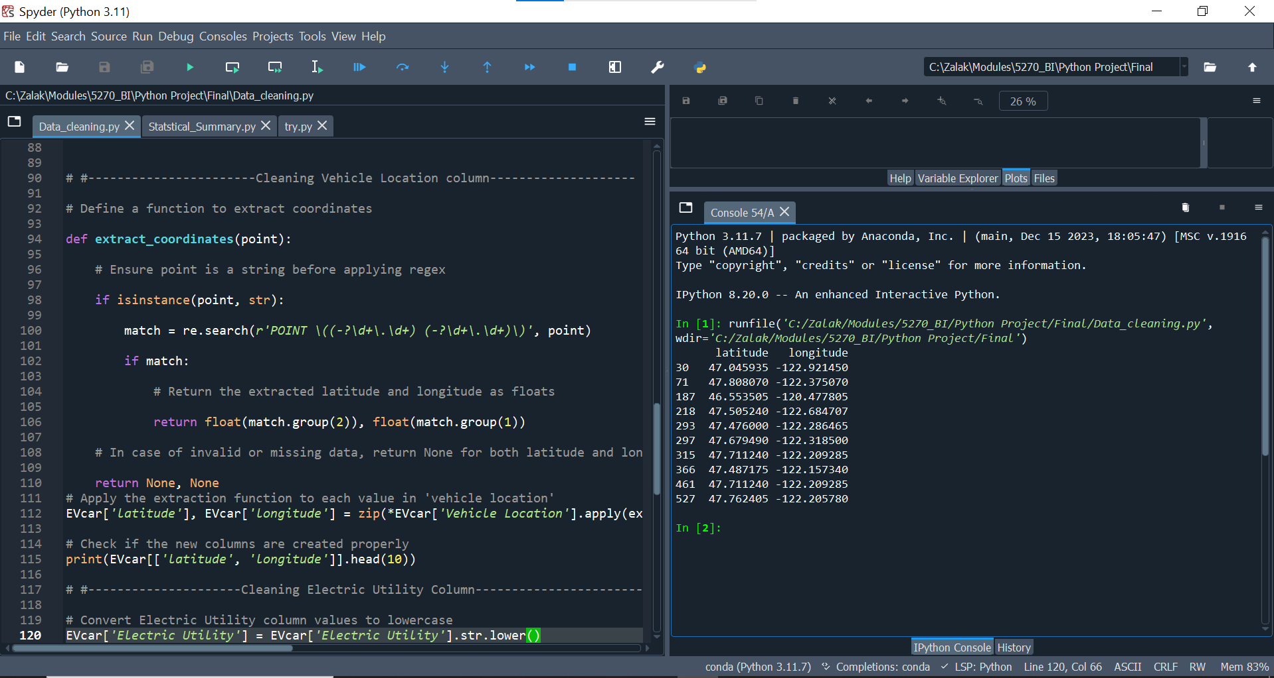

**Python Code:**

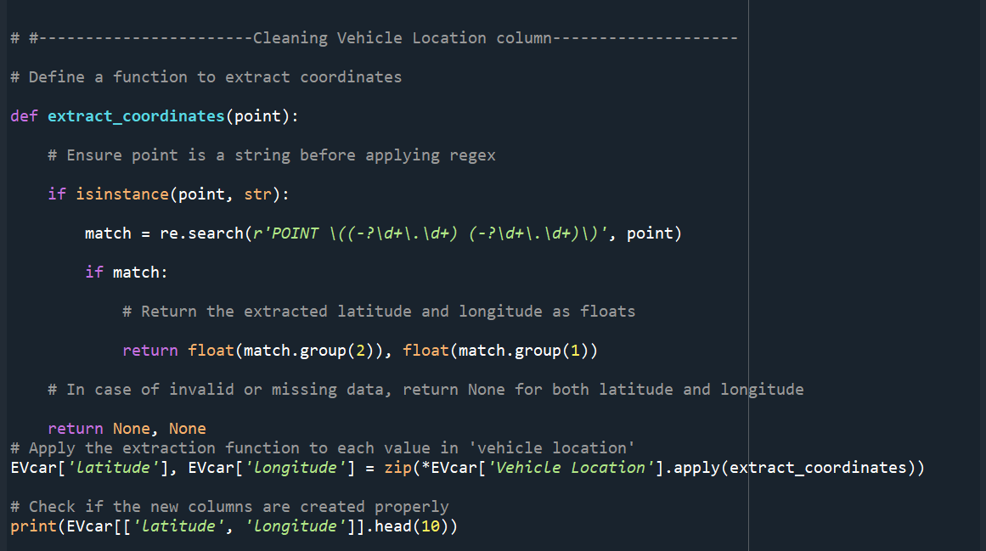

**Post-Cleaning:**

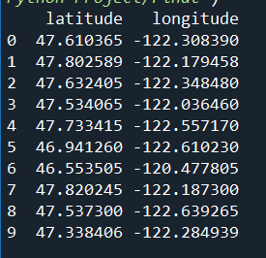

1. **Cleaning Electric Utility Column**

The final step in our data cleaning process for the Full Electric Vehicle Dataset 2024 was to clean the "Electric Utility" column. Our goal was to standardize the text by converting all characters to lowercase, replacing pipes (|) and double pipes (||), and removing the term "wa". We aimed to standardize this text to ensure that we could accurately calculate the total count of electric utility providers across the county for our analysis and we accomplished this using the following Python code:

**Pre-Cleaning:**

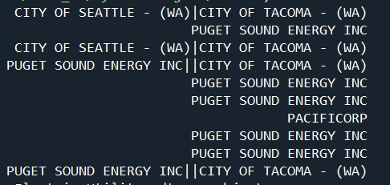

**Full Interface:**

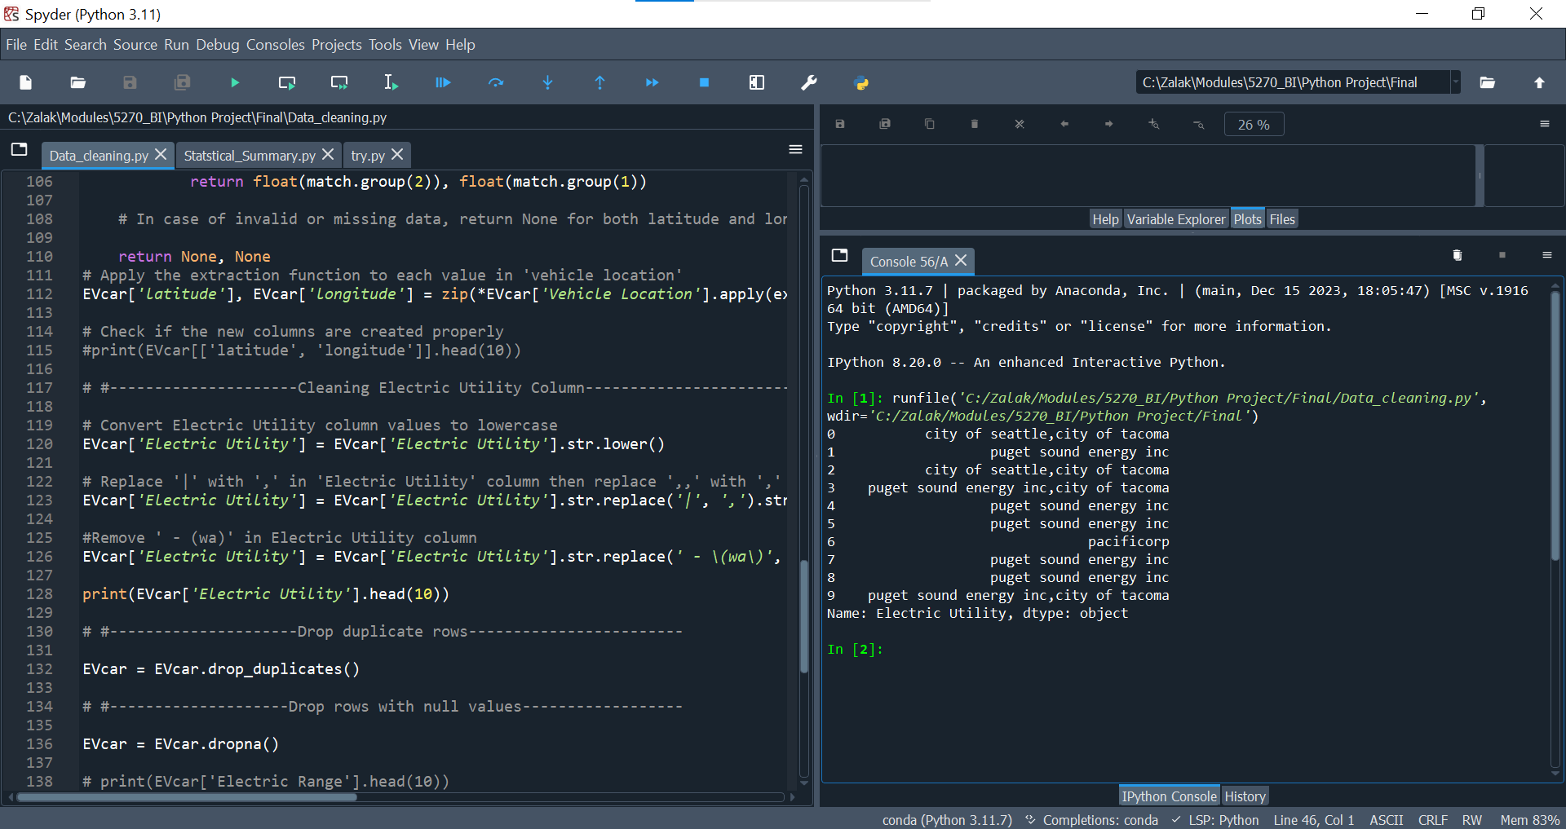

**Python Code:**

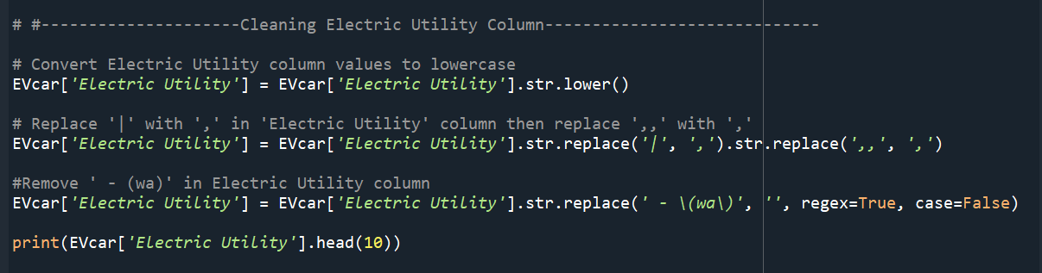

**Post-Cleaning:**

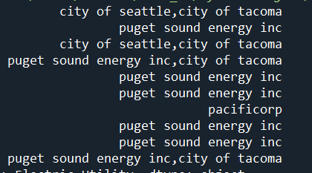

**Post-Cleaning Check:**

After completing all our data cleaning steps, we will check our data by running the following code:

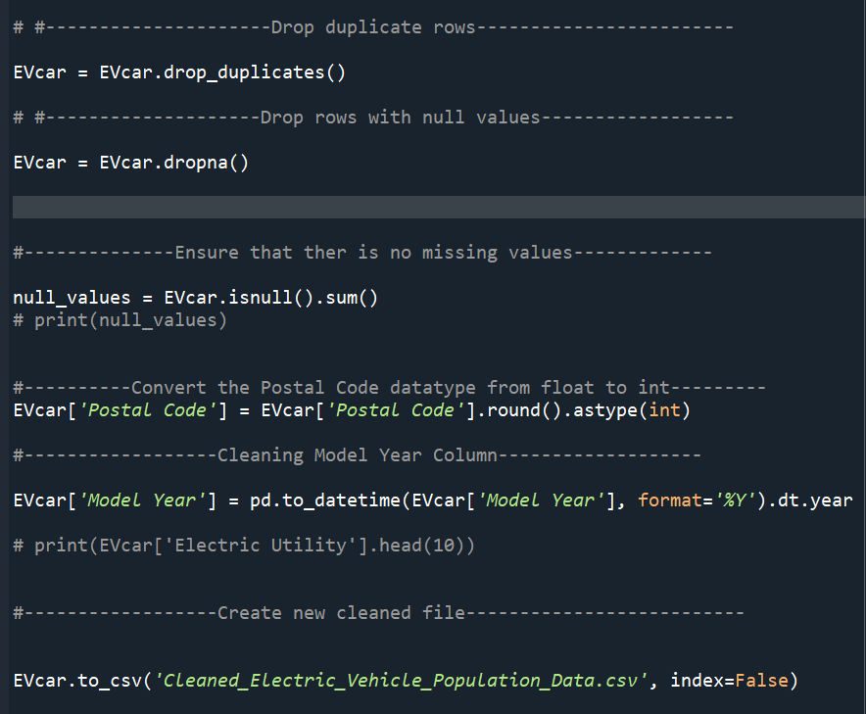

**Section D: Statistical Summary:**

1. **Getting the Total Rows & Columns**

**Full Interface:**



**Python Code:**



**Output:**

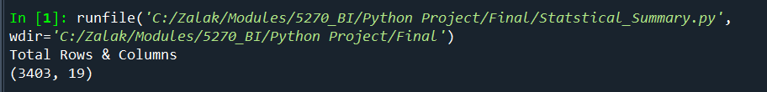

Output: **(**3403, 19)

Here, 3403 represents the row and 19 represents the column. By this we can understand that there are 3403 rows and 19 columns. Knowing the total number of rows and columns in a dataset can provide valuable insights into the data's size, completeness, quality, and structure.

1. **Getting concise Summary of a Data Frame**

**Full Interface:**

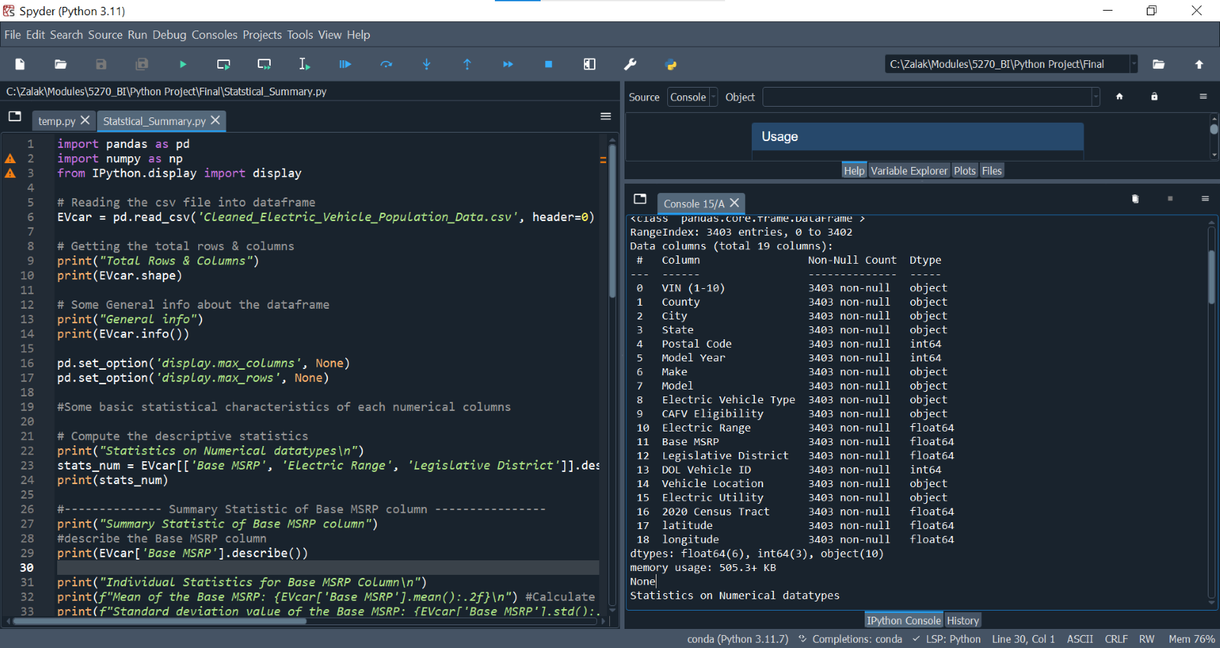

**Python Code:**

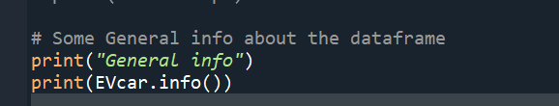

**Output:**

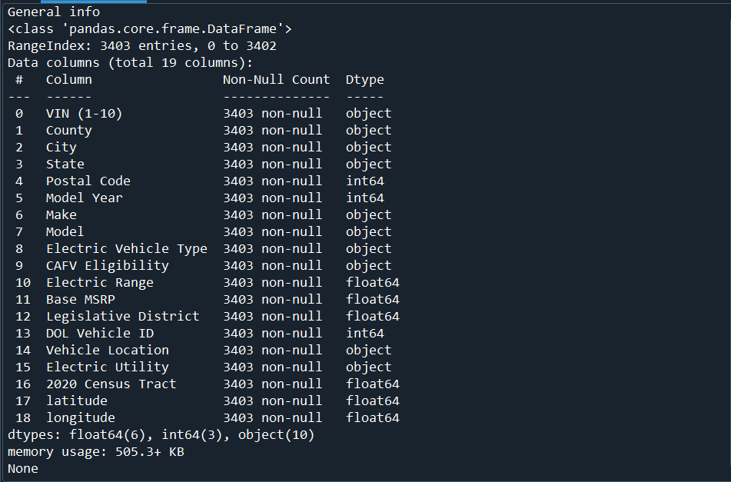

From the above output, we can see column names and their data types. We also can see the non-null values, null values in the dataset. Through the output, we can identify that all the columns are non- null.

1. **Statistic summary of Electric Range column**

**Full Interface**

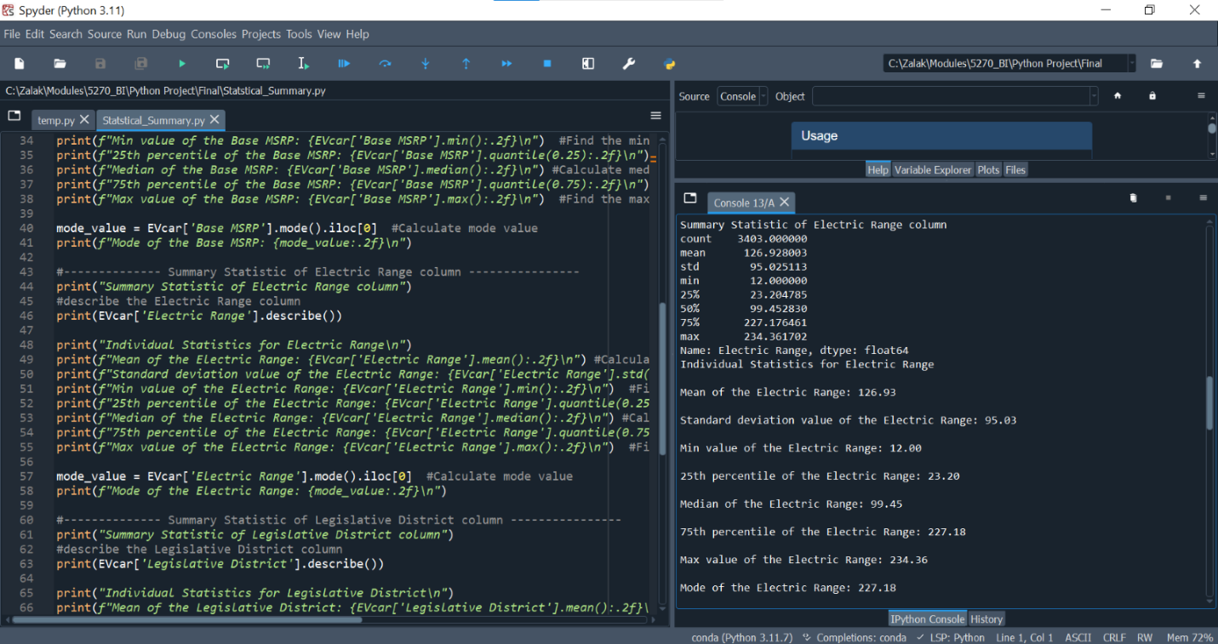  
**Python Code**

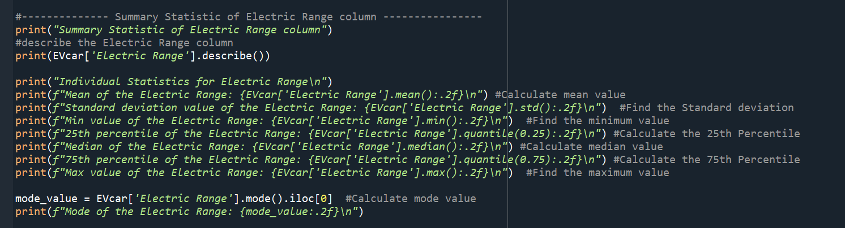

**Output**

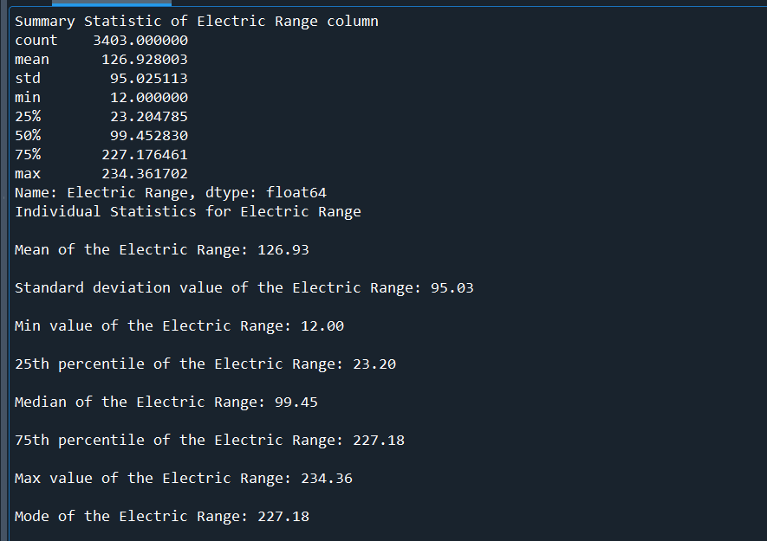

In summary statistic of the Electric Range column, count value represents that there are 3403 observations in the dataset. The mean or average electric range of vehicles is 126.93 miles, with a standard deviation value of 95.03 miles. This suggests significant variations in electric range among the vehicles, with most values differing from the mean by approximately 95.03 miles, on average. The electric range of vehicles in the dataset ranges from a minimum value of 12 miles to a maximum of 234.36 miles.

The mode value of the electric range column is 227.18 miles, meaning that this value is the most common electric range in the dataset. This suggests that most vehicles in the dataset have an electric range of 227.18 miles. The 50th percentile, or median value, stands at 99.45 miles, indicating that half of the electric vehicles have an electric range greater than 99.45 miles, while the other half have an electric range below this median value. The value of the 25th percentile, or first quartile, is 23.20 miles, meaning that 25% of electric vehicles have an electric range of 23.20 miles or less. Similarly, the value of the 75th percentile, or third quartile, is 227.18 miles, indicating that 75% of electric vehicles have an electric range of 227.18 miles or less.

1. **Statistic Summary of Base MSRP:**

**Full Interface:**

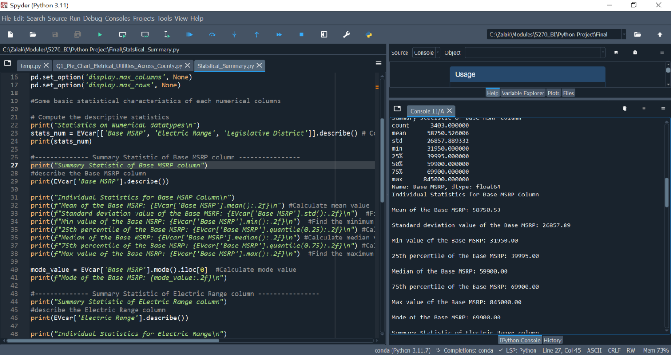  
**Python Code**

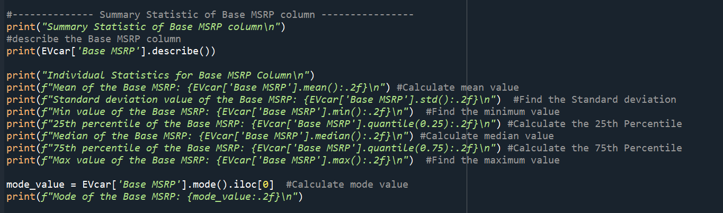

**Output**

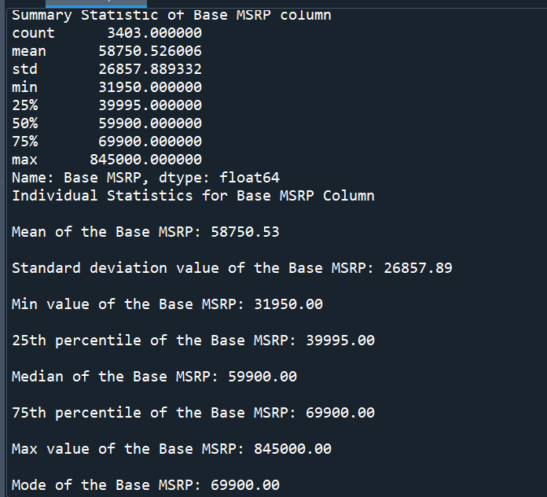

In summary statistic of the base MSRP column, count value represents that there are 3403 observations in the dataset. The mean or average base price of vehicles is $58,750.53, with a standard deviation value of $26,857.89. This suggests significant variations in base prices among the vehicles, with most values differing from the mean by approximately $26,857.89, on average. The base price of vehicles in the dataset ranges from a minimum value of $31,950 to a maximum of $845,000.

The mode value of the base MSRP column is $69,900 which indicates that $69,900 is the most common base price value in the dataset. This suggests that most vehicles in the dataset have a $69,900 base price. The 50th percentile, or median value, stands at $59,900, indicating that half of the electric vehicles have a price greater than $59,900, while the other half have a price below this median value. The value of the 25th percentile, or first quartile, is $39,995, meaning that 25% of electric vehicles have a price of $39,995 or less. Similarly, the value of the 75th percentile, or third quartile, is $69,900, indicating that 75% of electric vehicles have a price of $69,900 or less.

1. **Statistic Summary of Total Count of Vehicles in Washington State**

**Full Interface:**

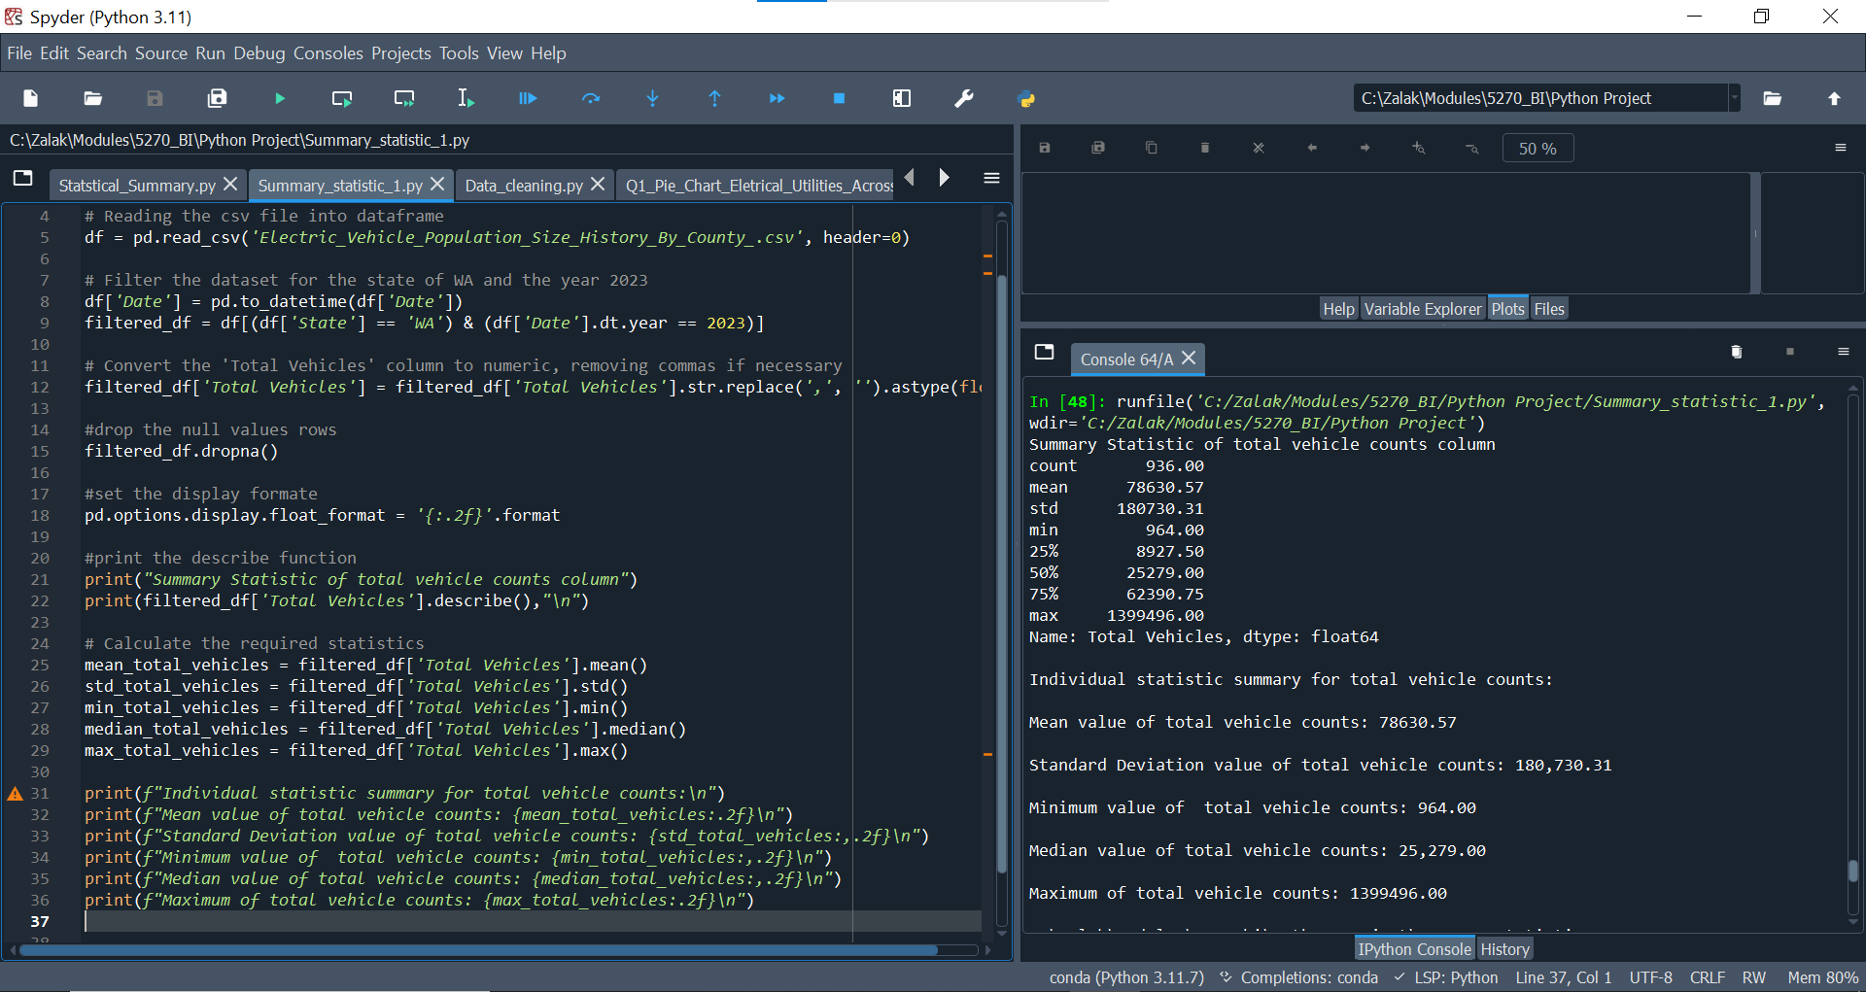

**Python Code:**

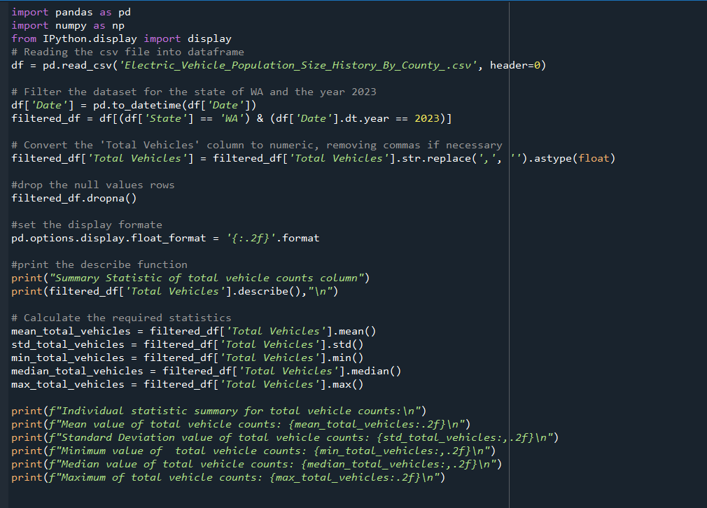**Output:**

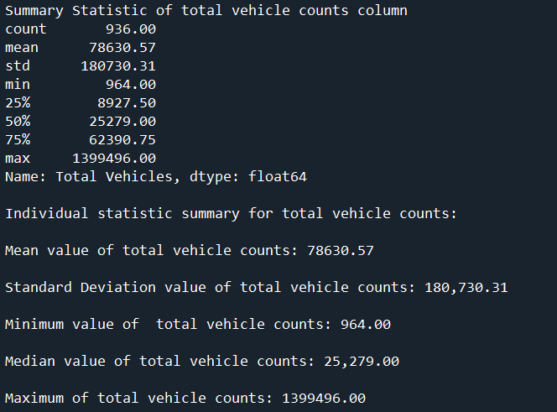

The data on total vehicle counts provides valuable insights into the distribution and central tendencies within the dataset. The mean value of the total vehicle counts indicates the average number of vehicles across the dataset, while the standard deviation reflects the variability around this mean. The wide range between the minimum and maximum values showcases the diversity in vehicle counts among different regions or categories.

Key insights from these statistics include the average total vehicle count of 78,630.57, suggesting a moderate level of adoption across the dataset. The high standard deviation of 180,730.31 indicates substantial variability, with some regions having significantly higher counts than others. The median value of 25,279.00 shows that half of the dataset has vehicle counts below this number, indicating a skewed distribution. The minimum and maximum values, 964 and 1,399,496 respectively, highlight the disparity in vehicle counts, with some regions having minimal adoption and others having extensive penetration.

Understanding these statistics is crucial for analyzing the overall trends and identifying regions with potential for growth or further investigation in the electric vehicle market. The significant variability and skewed distribution suggest targeted strategies are needed to address the disparities in adoption. Focusing on regions with lower adoption rates could help in creating more balanced and widespread electric vehicle use, ultimately contributing to a more sustainable and eco-friendly transportation system globally.

**Analysis and Visualizations**

**Analysis #1: Distribution of Electrical Utility Providers Across the County and Number of Electric Vehicles Per County.**

Our first analysis and visualization will illustrate the distribution of electrical utility providers across all counties in the state of Washington. This analysis aims to understand how electric utilities are distributed and compare their presence across the state. Additionally, we will compare the number of electric vehicles in each county.

**Full Interface:**

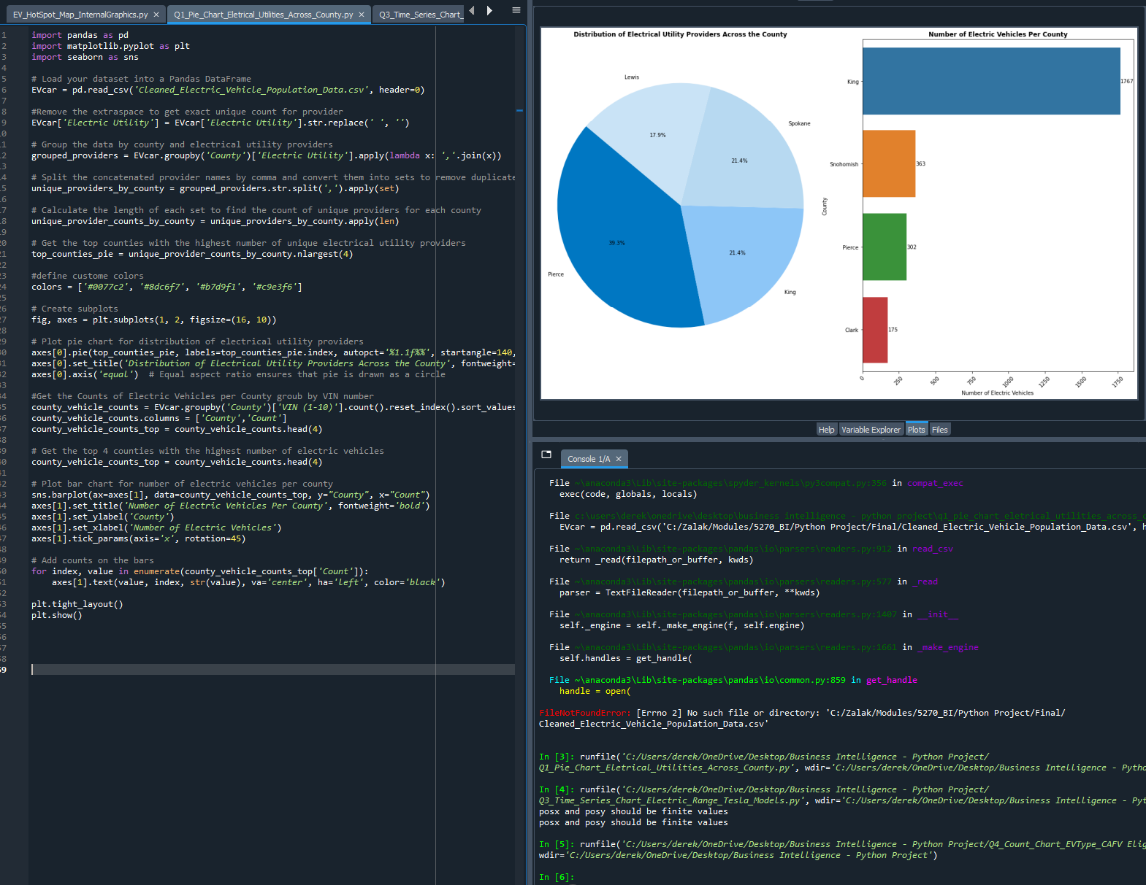

**Python Code:**

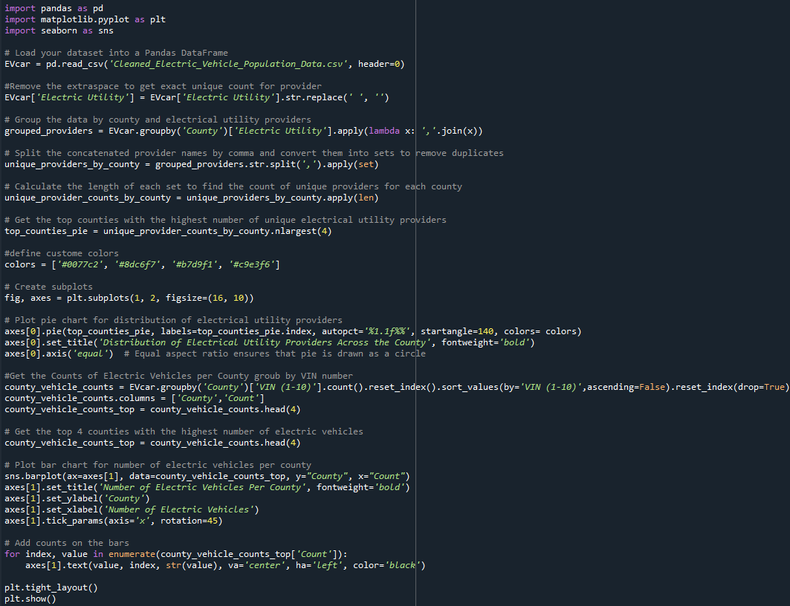

**Graphs:**

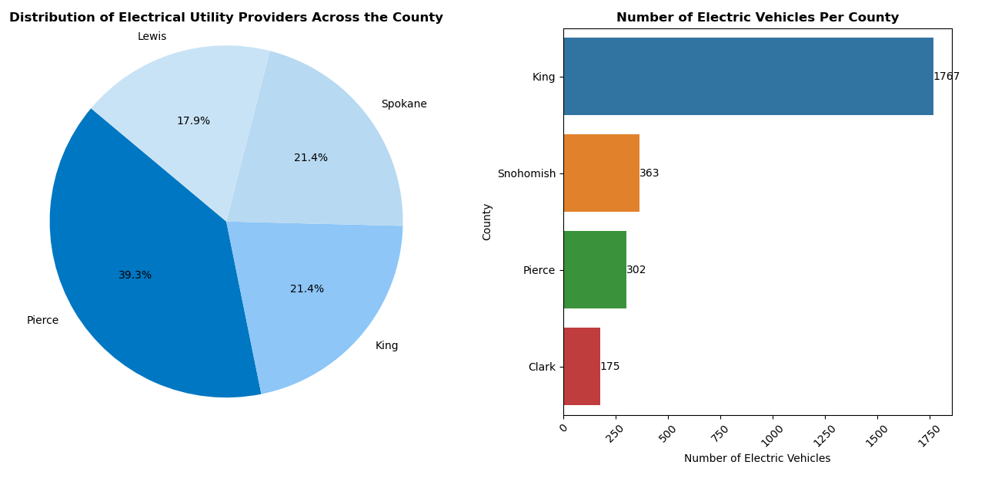

The attached graph contains two visualizations: a pie chart titled "Distribution of Electrical Utility Providers Across the County" and a bar chart titled "Number of Electric Vehicles Per County”. The pie chart illustrates the distribution of electrical utility providers in various counties in Washington. As you can see from the pie chart, Pierce County has the largest share, accounting for 39.3% of the distribution. King and Spokane County each hold 21.4% and Lewis County Accounts for 17.9%.

The distribution in the pie chart indicates that Pierce County has significantly higher proportion of electrical utility providers compared to the other counties, which may suggest a more extensive infrastructure and higher demand of electricity in order to power charging stations for electric vehicles.

The bar chart shows the number of electric vehicles in four counties. King county has the highest number of electric vehicles with 1767 vehicles. Snohomish County follows with 363 vehicles, Pierce County has 302 electric vehicles, and Clark County has the fewest, with 175 electric vehicles.

From these combined charts, several insights can be derived. There is a high correlation between electric vehicle adoption and utility provider distribution: King County, which has a significant number of electric vehicles (1767), also has a considerable share of the distribution of electrical utility providers (21.4%). This suggests that a well-distributed electrical utility infrastructure might be a crucial factor in supporting the adoption of electric vehicles.

Despite having the largest share of electrical utility providers (39.3%), Pierce County has only the third-highest number of electric vehicles (302). This could be due to factors such as population density and socioeconomic levels.

The data suggests a strong link between the availability of electrical utility providers and the adoption of electric vehicles in Washington state. However, other factors such as demographics and socioeconomic conditions also play significant roles. To increase the adoption of electric vehicles, counties with lower numbers of electric vehicles might need to focus on improving infrastructure and providing incentives to encourage residents to switch to electric vehicles.

**Analysis #2: Electric Vehicle Population Heatmap: Mapping Residential Electric Vehicles**

Our second analysis and visualization will focus on a heatmap showing the residential locations of electric vehicles throughout the state of Washington. This map will demonstrate where the highest concentrations of electric vehicles are located.

**Interface:**

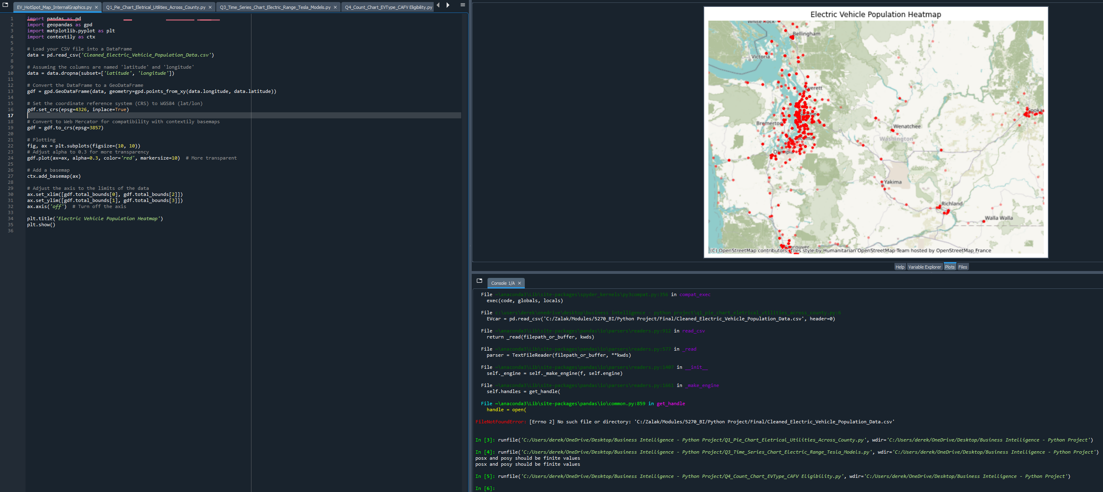

**Python Code:**

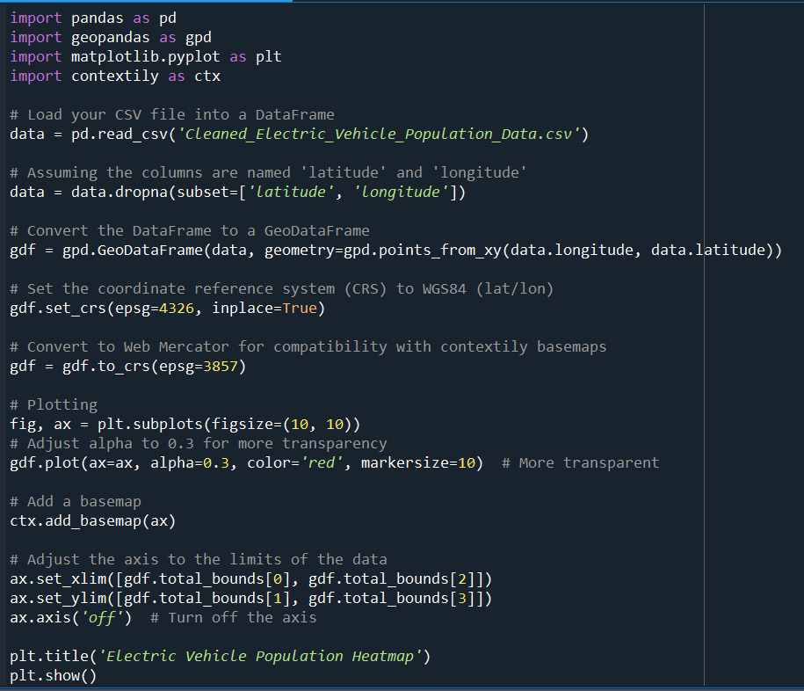

**Map:**

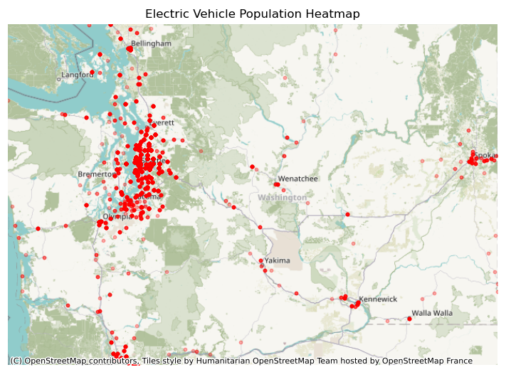

The attached map, titled "Electric Vehicle Population Heatmap," provides a visual representation of the distribution of electric vehicles (EVs) throughout the state of Washington. The heatmap uses red dots to indicate the residential locations of EVs, with denser clusters of dots representing higher concentrations of vehicles.

The Seattle metropolitan area, including nearby cities such as Everett, Bellevue, and Tacoma, shows the highest concentration of electric vehicles. This is evident from the dense cluster of red dots in this region. Other notable urban centers with significant EV populations include Spokane in the eastern part of the state and the Tri-Cities area (Richland, Kennewick, Pasco) in the southeast.

Rural areas and smaller towns across the state have relatively fewer electric vehicles, as indicated by the sparse distribution of red dots in these regions. This disparity may be attributed to socioeconomic factors or the need for trucks and larger automobiles in blue-collar jobs prevalent in these areas.

There is a noticeable pattern of EV presence along major highways and transportation corridors, such as Interstate 5 (I-5) running north-south through the state and Interstate 90 (I-90) running east-west. This suggests that access to infrastructure, such as charging stations along these routes, influences the adoption and distribution of electric vehicles.

The heatmap underscores the need for targeted infrastructure development in areas with growing EV populations, particularly in urban centers where demand is highest. Conversely, the relatively low EV density in rural areas suggests a potential barrier to adoption, possibly due to limited charging infrastructure or longer travel distances.

In summary, the heatmap provides valuable insights into the geographic distribution of electric vehicles in Washington State, highlighting areas of high adoption and potential gaps in infrastructure. This information is crucial for guiding future policy decisions, infrastructure investments, and efforts to promote the widespread adoption of electric vehicles.

**Analysis #3: Analyzing the Most Popular EVs: Yearly Electric Range Variation in Tesla Models**

Our third analysis and visualization will focus on the electric range of the most popular electric vehicles by model and year. We aim to determine whether newer models of these popular electric vehicles achieve better mileage than older models.

**Full Interface:**

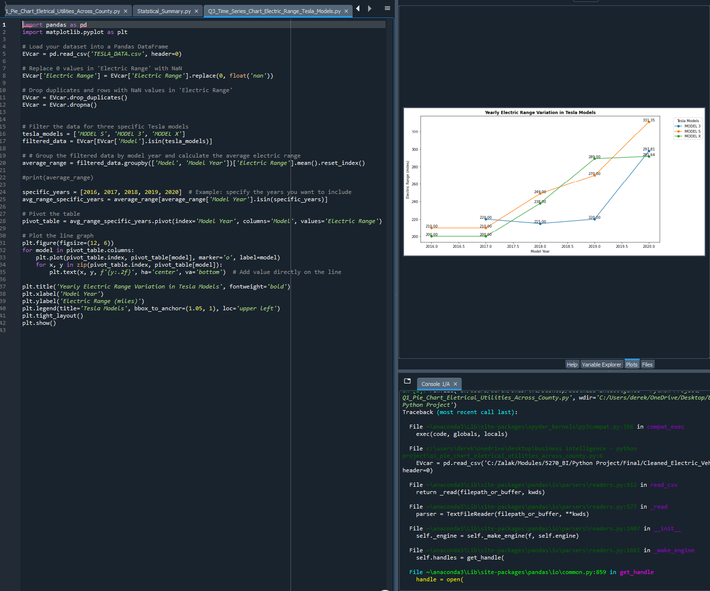

**Python Code:**

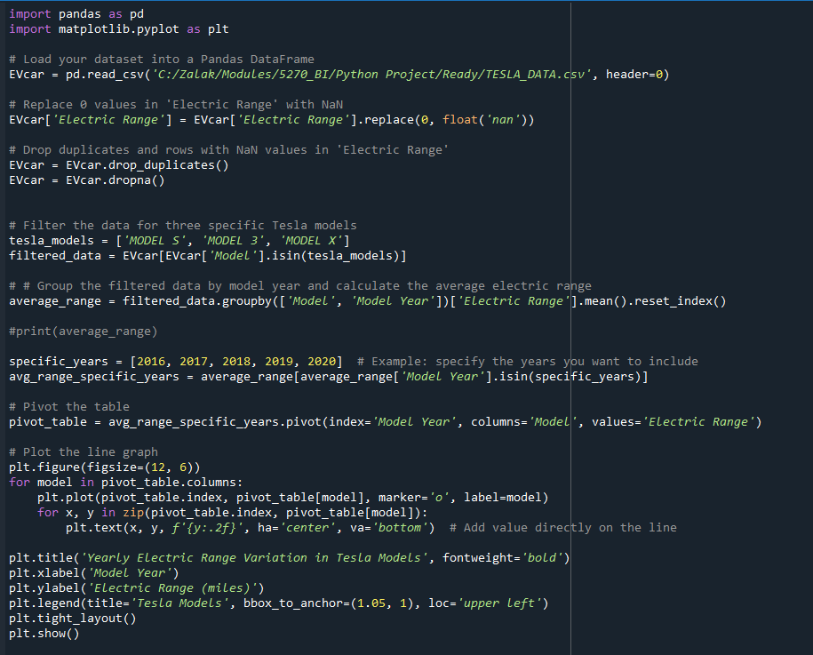

**Graph:**

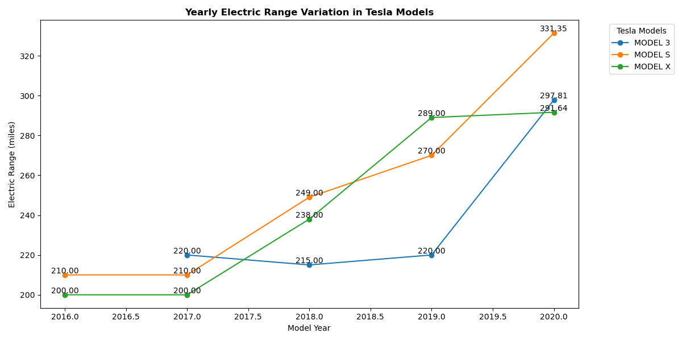

The attached graph, titled "Yearly Electric Range Variation in Tesla Models," illustrates the changes in electric range (measured in miles) for three Tesla models—Model 3, Model S, and Model X—over the years 2016 to 2020. The electric range represents the distance a vehicle can travel on a single charge.

All three Tesla models show a clear upward trend in electric range over the years, indicating improvements in battery technology and vehicle efficiency. The Model S starts with an electric range of 210 miles in 2016. There is a steady increase in the range over the years, reaching approximately 331.35 miles in 2020. This model exhibits the most significant improvement in range, with an increase of about 121.35 miles over the four-year period.

The Model 3 starts with an electric range of 220 miles in 2017, the year it was introduced. After a slight dip to 215 miles in 2018, the range increases significantly to approximately 297.81 miles by 2020. This model shows a substantial range improvement, especially between 2018 and 2020.

The Model X starts with an electric range of 200 miles in 2016. The range steadily increases each year, reaching about 291.64 miles in 2020. The total increase in range for this model is approximately 91.64 miles over the observed period.

By 2020, the Model S has the highest electric range at 331.35 miles, followed by the Model 3 at 297.81 miles, and the Model X at 291.64 miles. The graph highlights significant progress in extending the electric range for all Tesla models, with the Model S leading in terms of maximum range.

The consistent increase in electric range across all models suggests significant advancements in Tesla's battery technology and energy efficiency over the years. These improvements in electric range make these vehicles more appealing to consumers, reducing range anxiety and enhancing the practicality of electric vehicles for long-distance travel. The substantial increases in range help Tesla maintain its competitive edge in the electric vehicle market, showcasing its commitment to innovation and performance. Increased electric range also contributes to greater adoption of electric vehicles, supporting efforts to reduce greenhouse gas emissions and reliance on fossil fuels.

In summary, the graph effectively illustrates the progressive enhancement in the electric range of Tesla's Model 3, Model S, and Model X from 2016 to 2020, highlighting significant technological advancements and their implications for consumers and the environment.

**Conclusion**

In this study, we analyzed various datasets from Kaggle, including the "Full Electric Vehicle Dataset 2024," "American EV Dataset," and "Electric Vehicle Population by Country (2024)." Our goal was to gain insights into the adoption and distribution of electric vehicles (EVs) across different regions in the state of Washington.

These findings highlight the diverse landscape of electric vehicle adoption. While some regions exhibit high levels of EV adoption, others lag behind. Overall, our study provides a comprehensive overview of the current state of electric vehicle adoption, analyzing residential population patterns to determine where most residents drive EVs. Additionally, we examined how EV range is improving over time with the introduction of newer and more efficient technologies.

This analysis is crucial for understanding regional disparities in EV adoption and the impact of technological advancements on vehicle performance. The insights gained can inform policymakers and stakeholders in developing targeted strategies to promote more widespread and equitable adoption of electric vehicles, ultimately contributing to a sustainable and eco-friendly transportation system in Washington state.

References

Lucia, B. (2024, April 23). Washington electric vehicle rebates up to $9,000 available beginning in August. Retrieved May 12, 2024, from <https://washingtonstatestandard.com/2024/04/23/washington-electric-vehicle-rebates-up-to-9000-available-beginning-in-august/#:~:text=In%20March%2C%20there%20were%20about,million%20vehicles%20registered%20in%20Washington>

U.S. Energy Information Administration (2024, April 18). Washington Profile State Profile and Energy Estimates. Retrieved May 12, 2024, from <https://www.eia.gov/state/analysis.php?sid=WA>